First things first….

Read, read and more reading….
We are going to start with the first book of the Bible. I know others will tell you to start in John or Romans and you certainly can. But for this work we are going to start in the first book of the Bible, Genesis.
The Book of Genesis has 50 chapters. We begin by reading the first 4 chapters two times through. While reading don’t take any notes. Now after reading through twice….
We are going to read the first four chapters again but this time we are going to apply our “F.B.I.” skills.
We are going to give a title to each chapter, also group together verses and give them a short description. We derive at out titles and short descriptions by asking a few questions while reading through each chapter. What we “Observe” we record on our “Observation Chapter and Verse chart”.
F.B.I. Factual, Biblical, Investigation

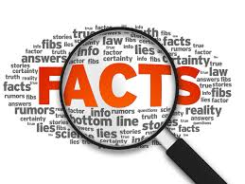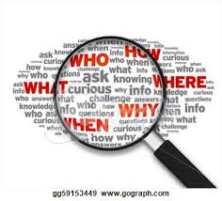
I have been repeating these words for a very long time now…. Who, What, When, Where, Why, and How. Did you know that the FRI also uses these words when conducting an investigation as well as the police?
Let’s take a closer look at them….. 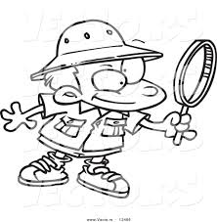

For our example we will use John 1:1
“In the Beginning was the Word and the Word was with God, and the Word was God.”
- Our first question… What was in the beginning ? answer… … the Word. Next Question….
- Who is the Word? …… answer… the Word was God. Next Question..
- Where was the Word? In the beginning …. Next Question
- When is …”In the Beginning?” Beginning of what? …… Gen.1:1 read it. Also … the beginning of “tic, tic, tic… time” Next question
- Other questions you could ask….. What took place in the Beginning…
- How was the beginning started and why?
As you continue to verse two in John you’ll notice your questions will be answered more directly. Also if you had started your study in Genesis you should have a number of great books filled with notes and charts that could help your answered to be filled with cross-references…. Special characters, topics, word topics, etc., etc. After a short time you’ll begin to create your own Reference Library.

As you continue other questions will come to mind such as these..
What is this chapter telling me? What are these verses saying?
Who is this chapter talking about and why? Where is this taking place? Why is the Holy Spirit telling me this? Why did God put this in writing? Why are these words being repeated?

Now all of this fact finding, and investigating must be recorded down somewhere. This is where your Bible study sheets come in. When you begin asking your probing fact finding questions after you finished you initial reading, your need to make a record for those answers. By doing so and taking the time necessary you will soon learn how to develop your own style and your own preferences. In a short time your Bible knowledge will increase and so will your hunger for more. I know after doing this for over 37 years I’m still searching and studying God’s word daily. It has become second nature for me to do so.

In our next teaching I will use one of the tools for gathering information and will show you how I do it. Until then …Ps. 3:5-6

