Bible School: Explanation of course
In today’s world, Bible schools have become a den filled with bible perverting scholars and bible correcting teachers. The attack on the King’s Bible, the Authorized King James Bible is real and demonic driven. It is an attack on the words of God just as it was back in the time during Jeremiah’s day. Disarming the body of Christ is Satan’s plan and it’s been working now for a long time.
Results: Our Churches are filled with weak minded Christians because they are ignorant of the word of God. The Pastors who run these Churches went to these perverted bible schools resulting in themselves being far too weak minded and ignorant to preach or teach the word of God. I have been inside far too many a local Church to witness this travesty first hand. The results of all of this has been a Nation that’s filled with bible illiterates and we can judge that by the people they elect, the laws these elected have passed, the immorality of our Government, inferior School system, government induced News Media, immoral Movie Industry, XX-rated Television programs, and the deterioration of the family with the passage of the gay rights marriage act which is a war on the family. No gay couple can produce a child after their kind. They need to go and recruit a child from a broken family in order to reproduce after their kind. Seeing for years now the immoral results from these schools I wonder if the administrators of these schools ever read what the qualifications for a Teacher is from the word of God.
Pride, Lust for Power, Greed, High-minded, worldly, idol worshipers (Codex Sinaiticus and Codex Vaticanus) both corrupt Greek manuscripts; are not the qualifications of a Bible Teacher, nor a Pastor, nor a Deacon.
“The Preach and His Preaching”

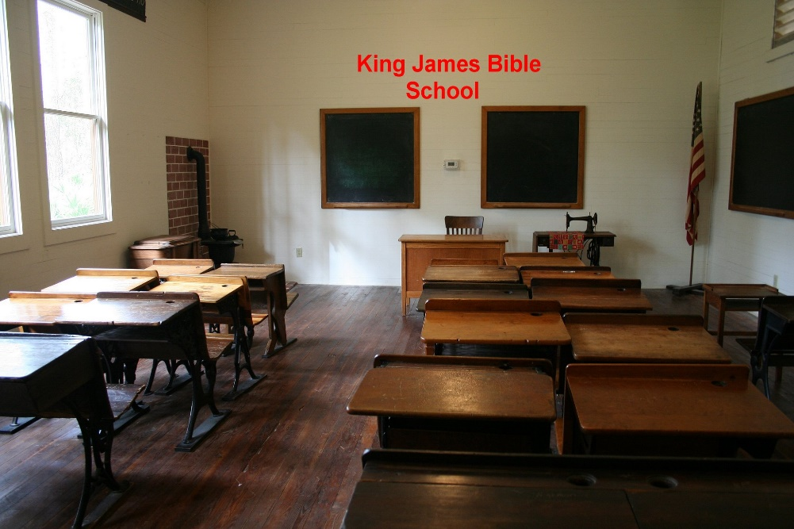
This is why it is so critical to have a place where true Bible believers can go and learn how to study the Bible, teach the bible and most of all be equipped with the words of God against all attackers and deceivers. We are to fight the good fight…Eph. 6:10-17, we have the sword of the word, Isa.. 11:1-4 not a wet noodle like the NIV, RSV, NASB, NKJB, etc., etc. You’ll never defeat the enemy with a rubber gun like this country wants to do by trying to control our guns. We need not to worry about Russia as much as we do with this Administration, Democrats and many Republicans and the so called Administrator and teachers at these Bible Schools.
How we are different and what do we offer…..
We have but one foundation on which we shall build upon.. that being our Lord and Saviour Jesus Christ. 1 Cor. 3:10-11 Those that listen to our Lords words shall be wise and build upon a ROCK SOLID FOUNDATION Matthew 7:24-28; Luke 6: 46-48
This Bible school here is based on the Authorized King James Bible and you can read our “statement of faith” to see what and why we believe. Our prayer is to be able to teach those who are willing to learn the word of God by applying the tools we equip them with. They well be able to search the Bible and learn on their own. They will be able to teach others and produce bible believers and teachers after their kind. Today we have Pastors who are not interested at all in producing bible students and those educated in the word of God. That would mean they would have to do some work and share some of their knowledge and we know they would never want do that. You see it’s all about control just as the Roman Catholic Church has demonstrated now for over 1500 years with their Priesthood, College of Cardinals and their Pope. Christ Jesus has made us free John 8:36; Gal. 3:1. We are free from the bondage of Rome and controlling Pastors. Many a Pastor today seek power and fame and are not at all interested in teaching their flock even when they are instructed to do so. Read 2 Tim and Titus on the qualifications of a Pastor, and Deacon. They aren’t about to give up any power or control. We are liberated from the bondage of corruption.. Romans 8:20-21. Those that trust and believe on the Lord Jesus Christ and Him alone are truly free.. Ps. 119:41-45; John 8:36.
You can go on other websites that also claim to teach the Bible, but I have found many of them fall way short as to the basic understanding of the Bible and worst of all how they mistreat and abuse the word of God by using bibles which are corrupted. The first thing I check out on those sites is what they think of the Bible and which one they use. That tells me all I want to know.
So on this site, we will give you the tools you need and a system for studying the bible that will forever change the way you read and study the Bible all the while increasing your love and knowledge of the word of God. Now isn’t that want you truly want from your Bible School? Let me know ….. E-mail when you have a chance. Jjulian1611@att.net
As Bible believers we know:
Scripture is the written word of God
Da 9:2 See also Ro 3:2; 15:4
Scripture is inspired and true
Jn 10:35; 2Ti 3:15
It must not be distorted or changed:
Dt 4:2; 12:32; Pr 30:6; 2Co 2:17; 4:2; 2Ti 2:15; Rev 22:19
It is to be read publicly:
Ne 8:1-8; 1Ti 4:13

It is to be meditated upon:
Ps 1:2; 119:15, 97
It is the test of orthodoxy:
Isa 8:20; Ac 17:11
Mt 22:29 pp Mk 12:24
It is the basis for preaching:
Ac 17:2; 18:28

The gospel as the word of God
It was preached by Jesus Christ
Mk 2:2 See also Mt 13:19-23 pp Mk 4:14-20 pp Lk 8:11-15; Mk 4:33; Lk 4:43 pp Mk 1:38; Lk 5:1
It was preached by the first Christians
1Th 2:13 See also Mk 16:20; Ac 6:2; 8:4; 11:1 to the Gentiles; Ac 13:5 to the Jews; Ac 15:35-36; 17:13; 1Co 14:36; 2Co 2:17; 4:2; Php 1:14; Col 1:25; 2Ti 4:2
It leads to numerical and spiritual growth within the church
Ac 6:7; 12:24; 13:49; 19:20; Col 1:5-6; 1Th 2:13 Paul stresses that the preached word is not merely a verbal message but a dynamic power which achieves things.
It must be preached
Ro 10:14; 2Ti 4:2
Descriptions of God’s word
It is true:
Ps 33:4; Jn 17:17

It is flawless:
2Sa 22:31 pp Ps 18:30; Pr 30:5
It is infallible:
1Ki 8:56; 2Ki 10:10
Ps 103:20 It is obeyed by angels.
It is eternal:
Ps 119:89, 152; Isa 40:8; 1Pe 1:25
Ps 119:103 It is sweet and delightful; Ps 138:2 It is exalted above all things; Isa 45:23 It is irrevocable; Eph 6:17 It is the sword of the Spirit; 2Ti 2:9 It is not chained; Heb 4:12 It is living and active; 1Pe 1:23 It is living and enduring.

It has power to save
Jas 1:21 See also 2Ti 3:15; 1Pe 1:23
It brings about the growth of the kingdom of God
Mt 13:23 pp Mk 4:20 pp Lk 8:15
It builds up the saints
Ac 20:32
Scripture, purpose of
Scripture has been given by God to lead people to faith and salvation. Through Scripture believers are nurtured in faith and led to spiritual maturity.
Scripture is intended to lead people to salvation
2Ti 3:14-15 See also Ps 19:7-11; Jn 20:30-31; Ro 10:8
Scripture is intended to lead believers to maturity in faith
By its teaching
2Ti 3:16 See also Dt 6:6-9; Ps 19:7-8; 119:9, 130; Col 3:16
By its rebuke and correction
2Ti 3:16 See also Ps 19:11-13; 1Co 10:11-12; Heb 4:12-13
By training in righteousness
2Ti 3:16 See also Dt 29:29
By its illumination
Ps 119:105, 130 See also 2Pe 1:19; 1Jn 2:8
By its encouragement and reassurance
Ro 15:4; 1Jn 5:13 See also Ps 19:8-9; 119:50-51, 76; Heb 12:5-6
By its record of God’s promises
1Ki 8:56; Ps 119:140 See also Eze 12:25; Lk 24:44; 2Co 1:19-22

By its trustworthiness
1Ki 17:24; Ps 19:7-11; 33:4 See also Ps 119:151, 160; Jn 21:24; Rev 21:5
Scripture is essential for spiritual growth and maturity
Ps 1:1-3 See also Mt 4:4; Jn 15:5-8; 17:17; Eph 6:10-17; 2Ti 3:14-17

The above verses may be taught at these present day bible schools but no one who teaches them believes them. The first thing one must have when they come to the word of God is a believing heart. If you believe by FAITH and receive Christ Jesus as your Saviour you please God and reward will be great. (Heb. 11:6) If your heart is right and you are willing to work hard and study God’s word as we lay out in this school programs, than you will be well on your way. The tools you’ll use here will be used for the rest of your life as you continue to study the words of God. Amen and Amen Pro. 3:5-6
By J.R.J.

